Figure S1. The epithelial spheroids after 21 days of cultivation.
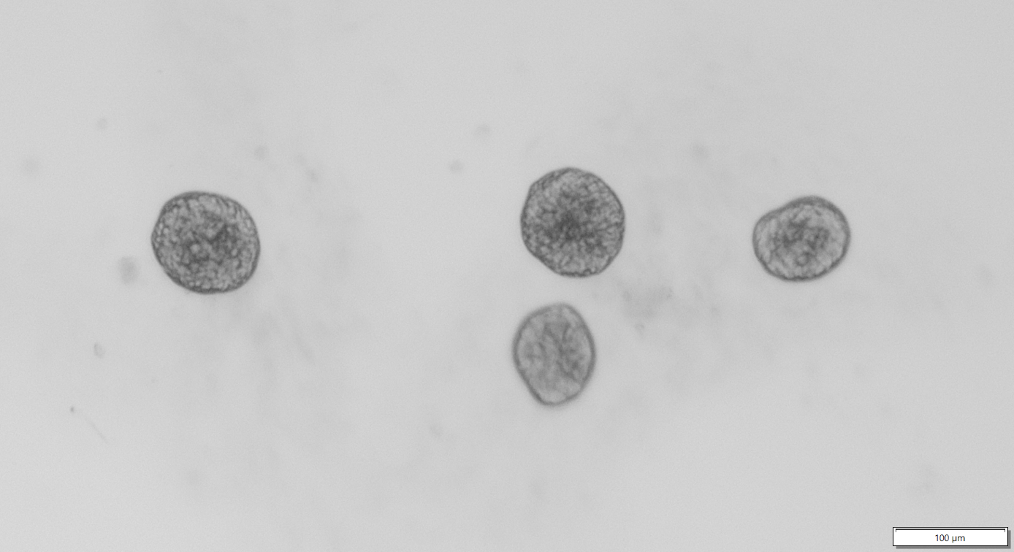
Figure S2. AHR, CD151, TLR4, EGFR, TGF-β expression in basal, ciliated, and secretory cells of epithelial spheroids of control, asthma, and COPD groups with or without PM_{2.5} stimulation. The data are presented as median fluorescence intensity (MFI). * p ≤ 0.05 within the group, comparisons between groups: &control vs asthma; # asthma vs COPD.
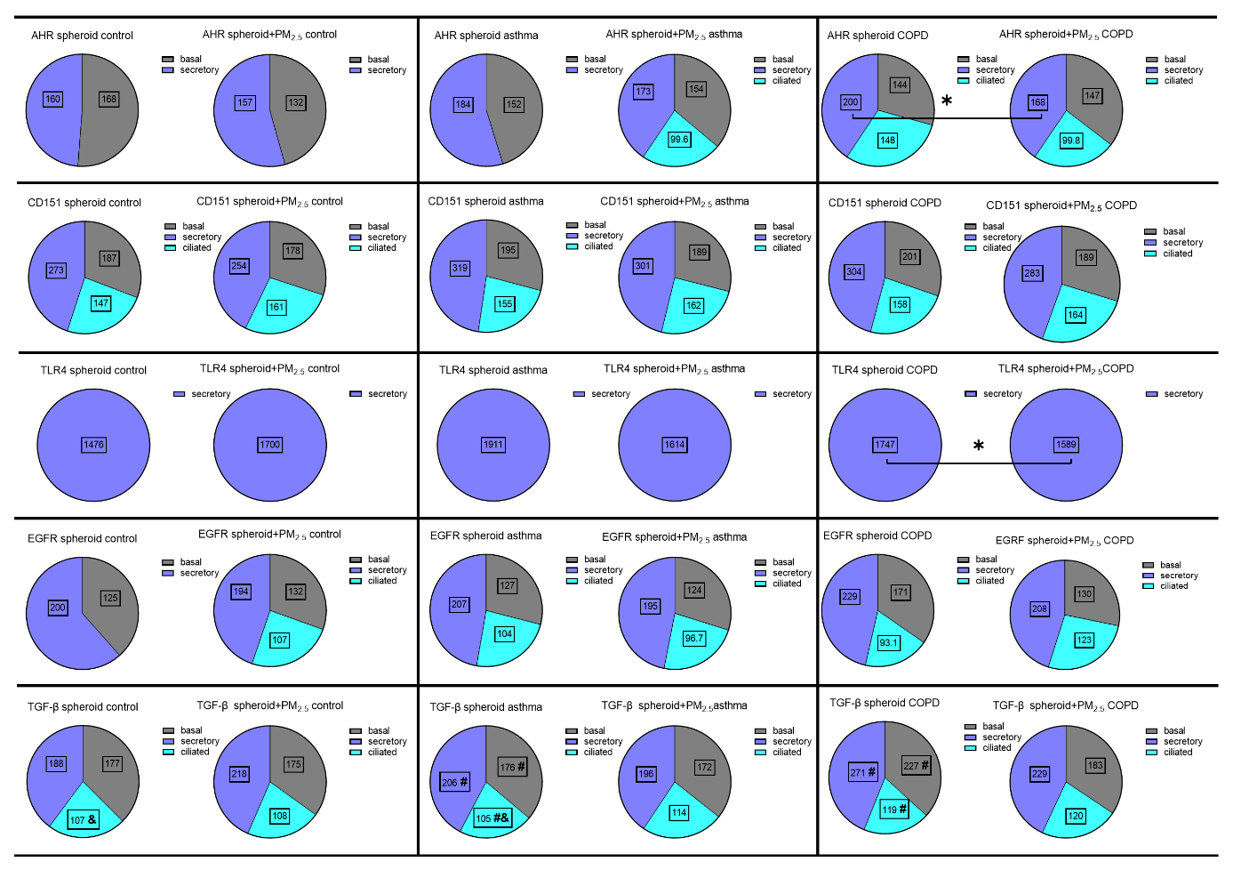
Table S1. Assay ID or sequence of primers and TaqMan probes (Thermo Fisher Scientific, MA, USA) used in real-time qPCR.
Gene symbol | Forward primer | Reverse primer | Probe | Product size
IL-1β | Hs01555410_m1 |  |  | 91
IL-6 | CCGGGAACGAAAGAGAAGCT | GCGCTTGTGGAGAAGGAGTT | TCTCCCCTCCAGGAGCCCAGCTA | 67
IL-8 | Hs00174103_m1 |  |  | 101
TNF-α | Hs00174128_m1 |  |  | 80
MMP7 | Hs01042796_m1 |  |  | 64
MMP9 | GCTCACCTTCACTCGCGTG | CGCGACACCAAACTGGATG | ACAGCCGGGACGCAGACATCG | 61
MUC5AC | Hs01365616_m1 |  |  | 55
BPIFA2 | Hs00395980_m1 |  |  | 68
ENPEP | Hs00989749_m1 |  |  | 70
TIPARP | Hs00296054_m1 |  |  | 80
TGF-β
EGF
18s rRNA | Hs99999901_s1 |  |  | 187

Table. S2 The characteristic of heavy metals in PM_{2.5} used in study.
Element | Concentration (µg/m³)
Cd | 0.014 (0.012-0.016)
Co | 0.019 (0.008-0.031)
Cr | 0.029 (0.023-0.033)
Cu | 0.017 (0.015-0.020)
Fe | 0.154 (0.098-0.257)
Mn | 0.000 (0.000-0.004)
Ni | 0.037 (0.000-0.080)
Pb | 0.004 (0.000-0.012)
Zn | 0.155 (0.118-0.196)
The results are presented as median and IQR.

Table S3. AHR, CD151, TLR4, EGFR, TGF-β expression in basal, ciliated, and secretory cells of epithelial spheroids of control, asthma, and COPD groups with or without PM_{2.5} stimulation. The data are presented as median and IQR.
 | control |  | asthma |  | COPD |  | p-value
 | spheroids | spheroids+PM_{2.5} | spheroids | spheroids+PM_{2.5} | spheroids | spheroids+PM_{2.5} | p-value
AHR
basal | 168.0 (143.0-170.0) | 132.0 (0.0-162.0) | 152.0 (149.0-180.0) | 154.0 (134.0-177.0) | 144.0 (0.0-156.0) | 147.0 (145.0-159.0) | n.s.
ciliated | 0.0 (0.0-0.0) | 0.0 (0.0-0.0) | 0.0 (0.0-122.0) | 99.6 (0.0-115.0) | 148.0 (0.0-189.0) | 99.8 (0.0-113.0) | n.s.
secretory | 160.0 (157.0-194.0) | 157.0 (154.0-166.0) | 184.0 (148.0-209.0) | 173.0 (156.0-189.0) | 200.0 (192.0-215.0)* | 168.0 (164.0-183.0)* | *0.02
CD151
basal | 187.0 (184.0-187.0) | 178.0 (175.0-251.0) | 195.0 (181.0-237.0) | 189.0 (186.0-270.0) | 201.0 (182.0-223.0) | 189.0 (181.0-228.0) | n.s.
ciliated | 147.0 (140.0-154.0) | 161.0 (158.0-170.0) | 155.0 (146.0-184.0) | 162.0 (160.0-239.0) | 158.0 (147.0-174.0) | 164.0 (147.0-208.0) | n.s.
secretory | 273.0 (264.0-314.0) | 254.0 (250.0-320.0) | 319.0 (290.0-356.0) | 301.0 (225.0-361.0) | 304.0 (293.0-344.0) | 283.0 (256.0-351.0) | n.s.
TLR4
basal | 0.0 (0.0-0.0) | 0.0 (0.0-0.0) | 0.0 (0.0-591.0) | 0.0 (0.0-0.0) | 0.0 (0.0-504.0) | 0.0 (0.0-618.0) | n.s.
ciliated | 0.0 (0.0-0.0) | 0.0 (0.0-0.0) | 0.0 (0.0-0.0) | 0.0 (0.0-0.0) | 0.0 (0.0-0.0) | 0.0 (0.0-0.0) | n.s.
secretory | 1476.0 (1414.0-1677.0) | 1700.0 (1689.0-1715.0) | 1911.0 (1564.0-2303.0) | 1614.0 (1519.0-1758.0) | 1747.0 (1704.0-1831.0)* | 1589.0 (1489.0-1685.0)* | *0.02
EGFR
basal | 125.0 (121.0-137.0) | 132.0 (127.0-134.0) | 127.0 (106.0-141.0) | 124.0 (122.0-140.0) | 171.0 (134.0-181.0) | 130.0 (119.0-140.0) | n.s.
ciliated | 0.0 (0.0-0.0) | 107.0 (97.3-108.0) | 104.0 (0.0-164.0) | 96.7 (0.0-185.0) | 93.1 (0.0-114.0) | 123.0 (0.0-125.0) | n.s.
secretory | 200.0 (194.0-248.0) | 194.0 (184.0-198.0) | 207.0 (184.0-228.0) | 195.0 (195.0-222.0) | 229.0 (214.0-251.0) | 208.0 (194.0-219.0) | n.s.
TGF-β
basal | 177.0 (176.0-191.0) | 175.0 (173.0-176.0) | 176.0 (165.0-180.0)# | 172.0 (169.0-189.0) | 227.0 (183.0-237.0)# | 183.0 (169.0-203.0) | #0.02
ciliated | 107.0 (102.0-109.0)& | 108.0 (103.0-116.0) | 105.0 (102.0-116.0)#& | 114.0 (110.0-118.0) | 119.0 (110.0-123.0)# | 120.0 (111.0-129.0) | &0.02 #0.03
secretory | 188.0 (172.0-325.0) | 218.0 (175.0-237.0) | 206.0 (176.0-270.0)# | 196.0 (172.0-273.0) | 271.0 (240.0-309.0)# | 229.0 (203.0-292.0) | #0.04
The data are presented as median fluorescence intensity (MFI). * p ≤ 0.05 within the group, comparisons between groups: &control vs asthma; # asthma vs COPD.

